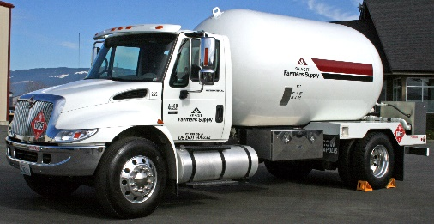

Skagit Farmers Supply, a local cooperative since 1934 based in Burlington, WA, serves farmers, homeowners, businesses, families and the communities in the Pacific Northwest. The company operates Agronomy, Propane, Refined Fuels, and Wholesale divisions as well as thirteen retail Country Store locations in Washington, Idaho and Montana. The company’s brands focus on commitment to provide quality products and services to our customers and community partners. The company is seeking candidates for a Propane Delivery (Bobtail) Driver to deliver bulk propane in Snohomish County.

**RESPONSIBILITIES & DUTIES**

Ideal candidates will possess an extremely high level of attention to detail, initiative, discretion and independent judgment, with a can-do attitude and the ability to multi-task. One who can see things that need to be done and figure out a way to do them effectively and efficiently. Candidates should be flexible and detail oriented with a great attitude while ensuring excellent customer service at all times. Job responsibilities include (but are not limited to):

* Safely operate all aspects of a propane bobtail to safely deliver propane to residential, commercial and industrial customers
* Accurately assess customer propane usage and perform billing procedures in accordance with established policies and procedures
* Perform safety checks on company and customer equipment through visual examination before dispensing fuel products
* Respond to and follow out-of-gas procedures
* Maintain a safe and clean working environment and equipment while adhering to OSHA, state and federal safety regulations
* Exhibit an ability to get along with others
* Practice punctual and reliable attendance
* Perform other duties as assigned

**JOB REQUIREMENTS**

* High school diploma (or equivalent), or any combination of education, training, or experience that provides the required knowledge, skills, and abilities with an emphasis on correctly calculating figures and amounts.
* Commitment to excellence and high standards especially in terms of providing outstanding customer service
* Physical ability to lift, carry, push and pull 60 pound (minimum) weight requirements.
* Professional appearance and demeanor
* Proven track record of being safe, dependable and reliable
* Ability to effectively communicate both verbally and in writing with co-workers and customers for safety purposes
* Strong organizational, multi-tasking, problem-solving, and analytical skills
* Possess a valid Class A or B Commercial Driver License (CDL)
* Must pass DOT physical, background check and pre-employment drug screen as a condition of employment
* Ability to follow directions verbally, written and on maps

**PREFERRED QUALIFICATIONS**

* Possess CDL tanker and hazardous materials endorsements (required if hired)
* Previous experience operating commercial vehicles with a DOT-regulated employer, preferably a propane bobtail or other petroleum delivery vehicle
* Demonstrate a willingness to work long hours and/or weekends

**HOURS / DAYS / SCHEDULE**

This is a full time, 40+ hours per week position, typically Monday - Friday. Qualified applicants must be available to work evenings and/or weekends as needed, especially during times of high seasonal demand (winter).

**SALARY / WAGE / BENEFITS**

A wage will be discussed during the interview process. In addition to generous employee discounts, the company offers medical, dental and life & long term disability benefits to full time employees. Employees may also participate in the company’s 401(k) plan after meeting eligibility requirements.

**TO APPLY**

Submit completed Commercial Driver Applications for Employment to one of the following:

**Mail**: Skagit Farmers Supply

Human Resources

PO Box 266

Burlington, WA 98233

**Fax:** (360) 757-4143

**Email**: [HR@skagitfarmers.com](mailto:HR@skagitfarmers.com) *(reference “Propane Delivery Driver” in subject field)*

Commercial Driver Applications for Employment may be obtained at any Skagit Farmers Supply location or at: <http://www.skagitfarmers.com/company/careers/>.

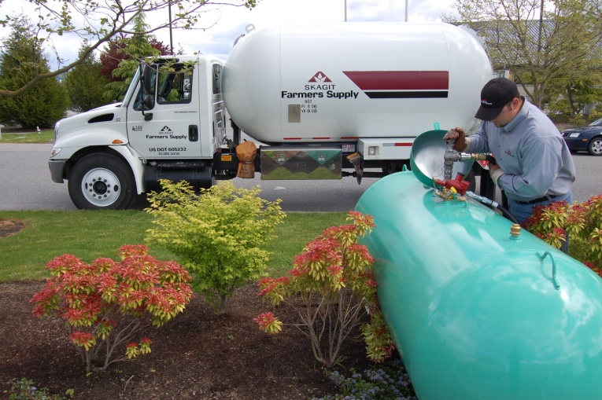

Skagit Farmers Supply Logo Color**www.skagitfarmers.com**